Final Project: Milestone #4

CIS 9440 - Data Warehousing for Analytics

Final Project Milestone 4

Due: May 8th, 2021

Group Number - <number>

Student(s) - <name>

For your Final Project, you/your project group will design and develop a Data Warehouse for Analytics following the Kimball Lifecycle.

In Project Milestone #1, you/your project group completed a Project Proposal that included:

* A project idea, motivation, and description
* Business Justification for the project
* Technical Justification for the project
* Identified at least 2 data sources to use for your project
* Created at least 5 KPI’s your Data Warehouse will measure

In Project Milestone #2, you/your project group designed a Dimensional Model that included:

* Completed Kimball Bus Matrix
* Dimensional Model that will be able to produce your KPI’s
* Refined list of KPI’s

In Project Milestone #3, you/your project group designed a Dimensional Model that included:

* Implemented an Extract, Transform, Load (ETL) process to load your data found in Milestone #1 into Facts and Dimensions you designed in Milestone #2

**For Project Milestone #4**, you/your project group will design and develop a Business Intelligence Application(s) to display/deliver your Project KPI’s. To accomplish this, you/your project group will complete the following:

1. From your current KPI’s, choose and list the most important 3-5 KPI’s from you will deliver with a BI Application(s).
2. Choose the best type of Visualization for each of your selected KPI’s.
3. Create a BI Application Wireframe design (page 364 in Business Intelligence Guidebook) of a Dashboard(s) to display the chosen KPI’s. Note, you may design and create multiple dashboards if needed.
4. Connect your Facts and Dimensions on BigQuery to Tableau, take a screen shot of your “Data Source” tab in Tableau after connected.
   1. Important note: you may need to use a “Union” in Tableau to connect multiple Fact tables to Dimensions. Also, you may use as many Data Sources as needed in Tableau by clicking “Data -> New Data Source” while on a worksheet tab in Tableau.

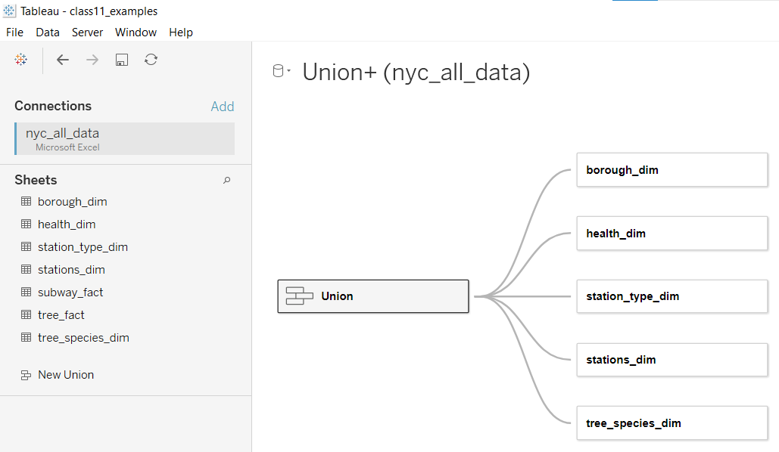

1. Develop each visualization of your Dashboard in a Tableau Worksheet. Make sure to appropriately name each worksheet to easily identify its intended purpose.
2. Put all your worksheets together on a Tableau Dashboard(s). Save your work.
3. Create a “Data Extract” of your data. To do this, select “Data -> hover over data source -> Extract Data”
4. Publish your Dashboard(s) to Tableau Public. You may need to create a (free) Tableau Public account if you do not already have one.
5. **To submit this Milestone #4**, please complete and submit the following template: [link](https://drive.google.com/file/d/1py8-XUy6HwesokiwUG-JKYa3qS-YuYR1/view?usp=sharing)